

BOOF QUEST

GAME DOCUMENTATION



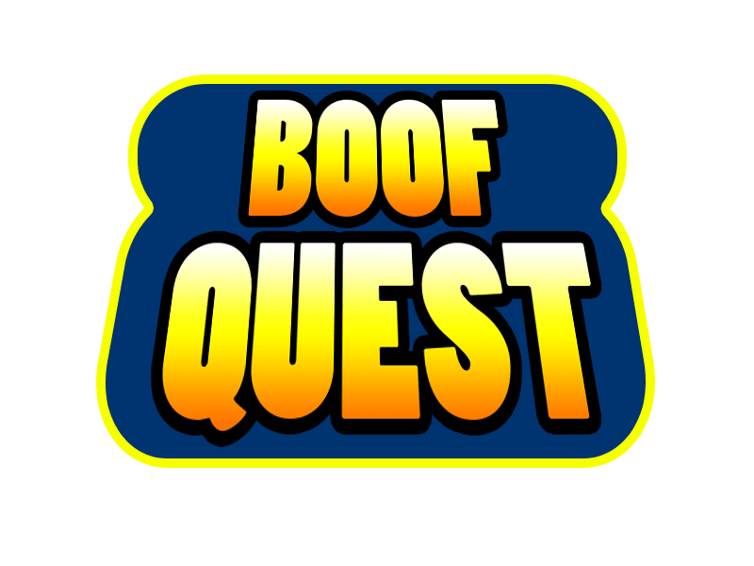

January 7, 2016

SIMON CHAWLA

Table of contents

# Content Page #

## Boof? : Game Concept and Synopsis

## Gameplay

* Power Ups
* Enemies
* Level Goals

## Storyboard

## But How?

Boof?

# Game Concept and Synopsis

Meet Boof. An ordinary law abiding citizen of the breakfast kingdom. A happy piece of toast. He enjoys a peaceful life along with all of his friends and family. Or at least he used to…

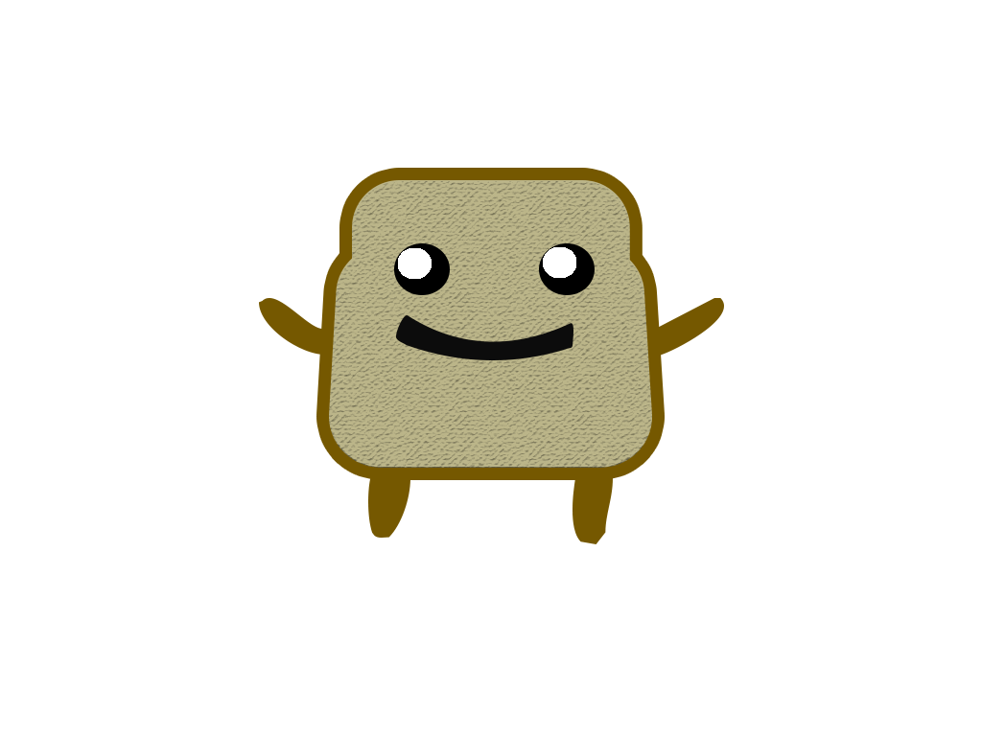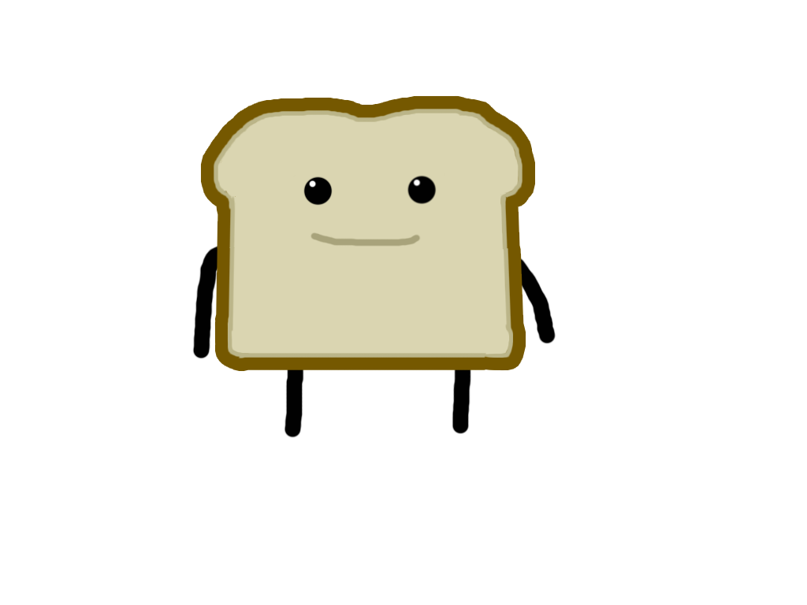

(Design change to Boof. Original on the left, new design on the right)

Everything changed when the milk went bad… The dairy to be specific. A jug of spoiled milk known as Doctor Curdle unplugged the cooler that kept dairy villa cool. Immediately there was separation, non-dairy vs dairy, the two sides divided and the dairy soldiers kidnapped Boof’s girlfriend Addy (a piece of French toast). Boof must break out his friends out of captivity (Barry the Butter Stick who was captured by non-dairy soldiers and PB & Jan who were captured by dairy soldiers) and stop Dr. Curdle.

The game will have four levels in total and is formatted in the style of a 2D platformer. In the first three levels

GAMEplay

# Enemies

# Moldy Jack

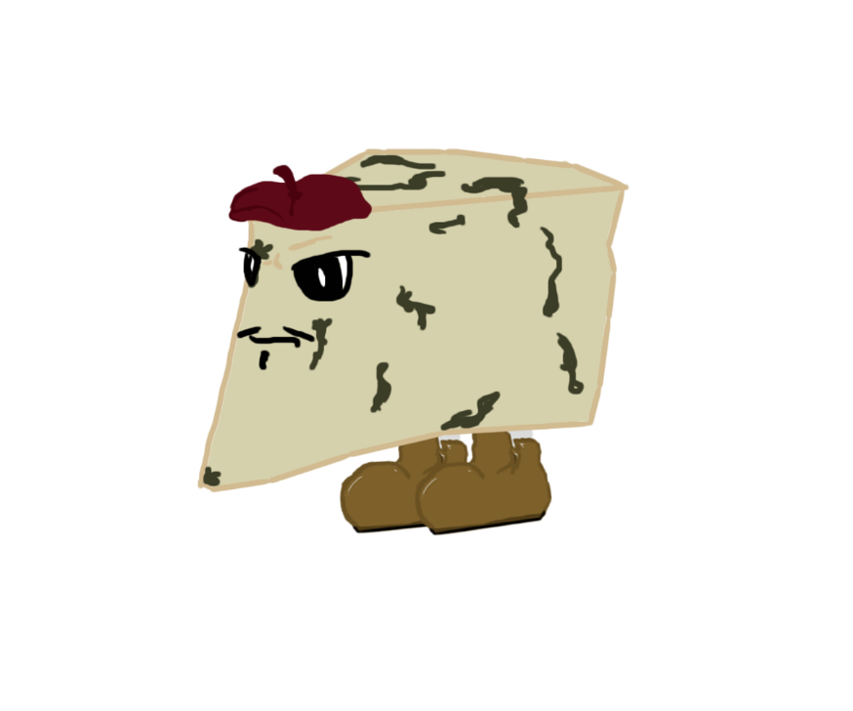

# Dr. Curdle

# Power Ups/Main Characters

## Addy

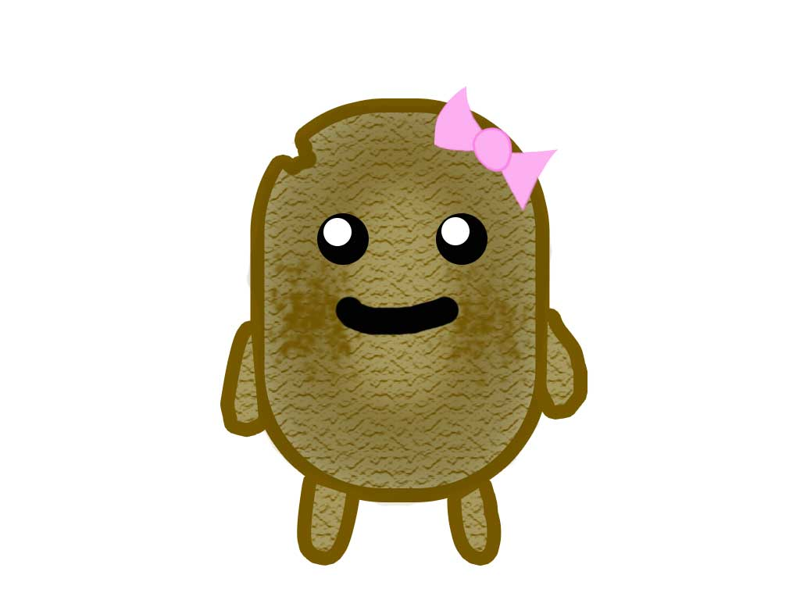CHARACTER ONLY

Addy is Boof’s girlfriend. At the beginging of the game she was captured by doctor Curdle and is being held captive at his layer. Boof must clear his way to Dr. Curdle’s layer to save his love.

## Barry Butterstick

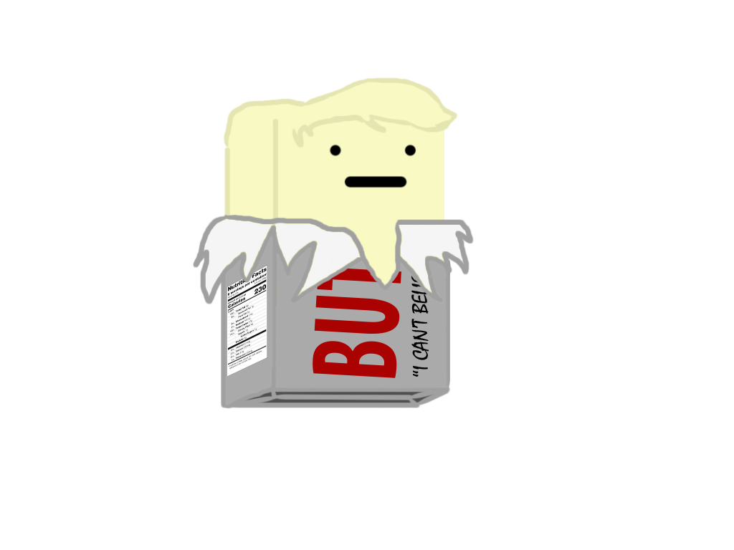

CHARACTER & POWERUP

Boof’s good friend Barry. A rather glum fellow who is quite cynical at times. He was captured by the non-dairy army because they assumed that he had gone bad like the rest of the dairy, but as you know… butter doesn’t go bad. In the game he serves as a power up, he makes Boof slippery so he can slide around with ease.

## Peeb Spread

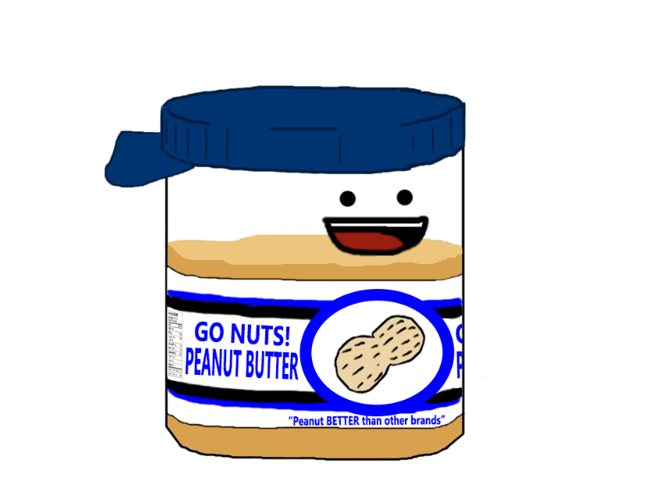

CHARACTER & POWERUP

Peeb is Jan’s little brother. Him and Boof love to play baseball together. After you free Barry, Boof goes to the next level to free Peeb. Peeb acts as a power up and allows Boof to stick to walls as well as wall jump.

## Jan Spread

CHARACTER & POWERUP

Peeb’s big sister who was also captured by Dairy forces. After freeing Peeb you must find Jan and save her. Jan acts as a power up and allows Boof to use her jam like Jam like properties to make yourself bouncy, and since Jan is a jam of the seeded variety, Boof is able to shoot seeds at enemies.

But HOW?

# JavaScript Libraries

Here are a list of JavaScript libraries that I will be utilizing to make this project happen as well their purpose on the project.

# CreateJS

* + Sprite Animation
  + User Controls

# RenderJS

* + Loading Tiled TileMaps